

Version Number: 1.2

Version Date: 2019-05-07



Revision Log

|  |  |  |  |
| --- | --- | --- | --- |
| Version | Date | Author | Change Description |
| 1.0 | 2019-05-04 | Luke Thompson | Initial creation |
| 1.1 | 2019-05-05 | Luke Thompson | SLAs Added |
| 1.2 | 2019-05-07 | Luke Thompson | Completion |
|  |  |  |  |

Contents

1. Overview 3

2. SLAs 3

2.1. Logic Overview 3

2.2. SLA - In Progress Letter Sent Date (10 days) 4

2.3. Install Date 5

3. Business Process 6

4. Automation 7

4.1. Order Type – Installation Date and Form Logic 7

4.2. Approval Logic 8

4.3. Create TELUS Order 8

4.4. Revised Scheduled Date 8

5. Business Process Flow – Order Flow 9

# Overview

The purpose of this document is co clearly outline the purpose of the Order entity, and to highlight the logic driving the system. The Order component in NGN’s Dynamics 365 instance is built to handle and track requests for service changes between School Districts and Vendors.

An Order will normally be created automatically following on form a completed Case. This will pull data from that case into the Order

An order has multiple Order Types, a Business Process flow, a Dashboard, SLAs and notifications.

# SLAs

## Logic Overview

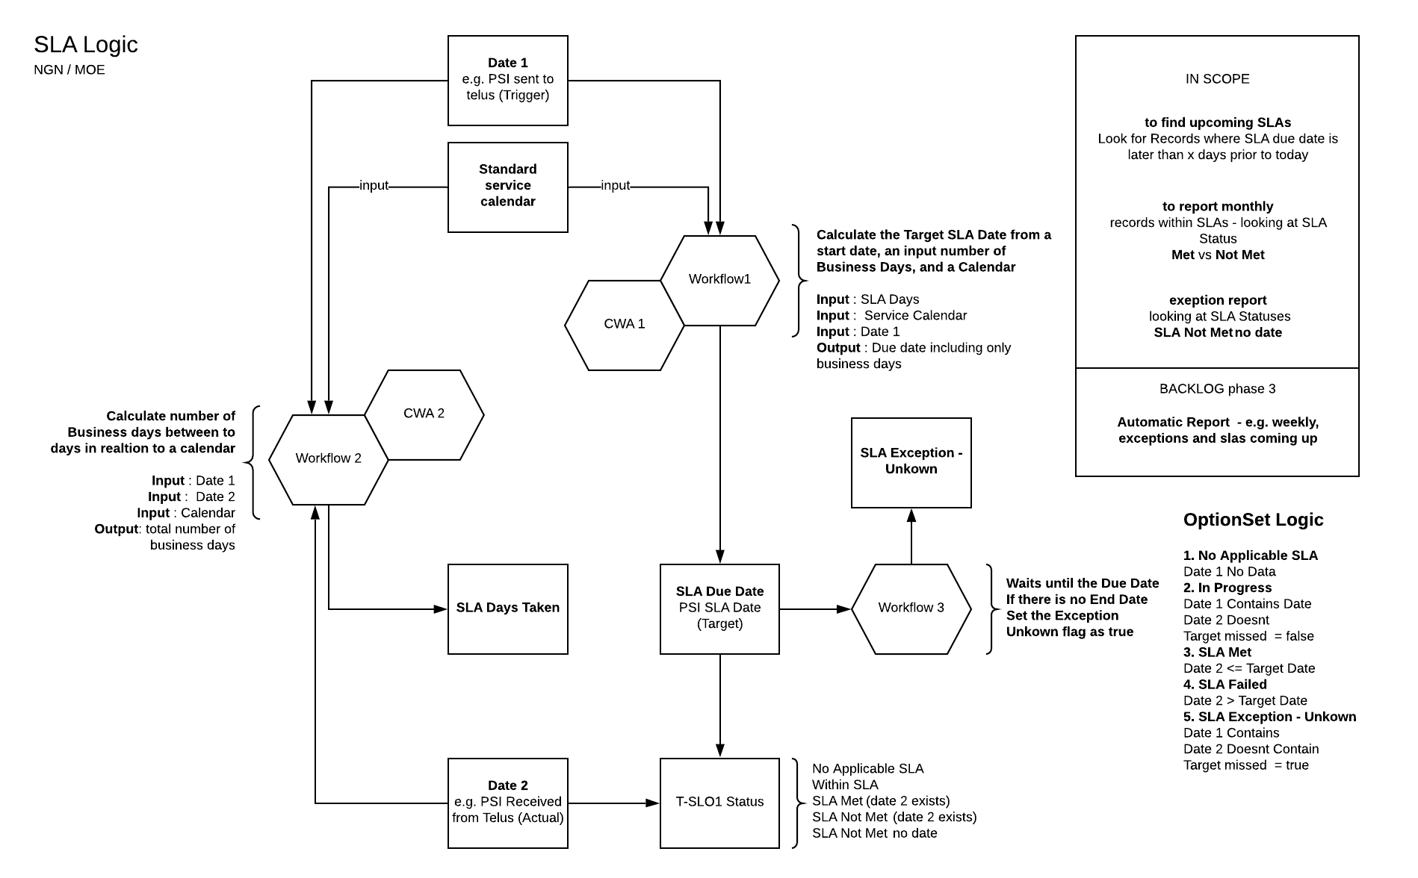There are two SLAs on the Order which this section. They follow the following logic

## SLA - In Progress Letter Sent Date (10 days)

This Tracks the SLA Days and status between the **Approval Date** and the **Sent date**.

Multiple workflows are used to calculate this.

Note: All day and date calculations are made with respect to the NGN business calendar.

1. On **Approval date** being set will fire a workflow to calculate and set the **Target Date**
2. On **Target Date** is set, a workflow runs and waits until that **Target Date**.
3. On **Target Date** is reached, if the **In Progress letter Sent Date** is not set, the exception flag (hidden field) is set, as we do not know if the SLA has passed or failed.
4. On **In Progress letter Sent Date** is set, a workflow calculates the SLA business days between the **Approval Date** and **In Progress letter Sent Date**

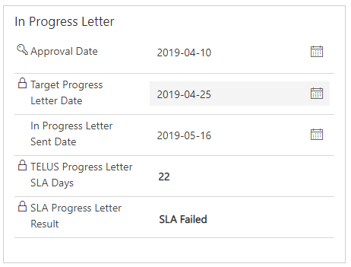

Finally, **The SLA Progress Letter Result** is a Calculated field which compares the values of Each field along with the exception flag to give one of the following outcomes:

1. No Applicable SLA
   * Date 1 No Date
2. In Progress
   * Date 1 Contains Date
   * Date 2 doesn’t contain date
   * Target Missed Flag = false
3. SLA Met
   * Date 2 <= Target Date
4. SLA Failed
   * Date 2 > Target Date
5. SLA Exception - Unknown
   * Date 1 Contains
   * Date 2 Doesn’t Contain
   * Target Missed Flag = true

## Install Date

This is Identical to the SLA above, except the fields used are:

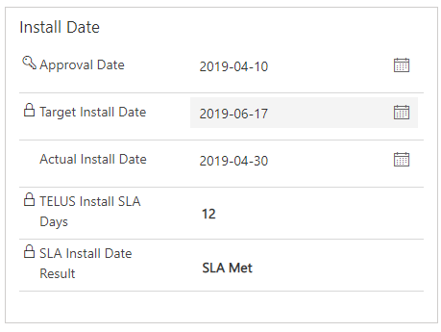

# Business Process

The system has been designed to support the business process below.

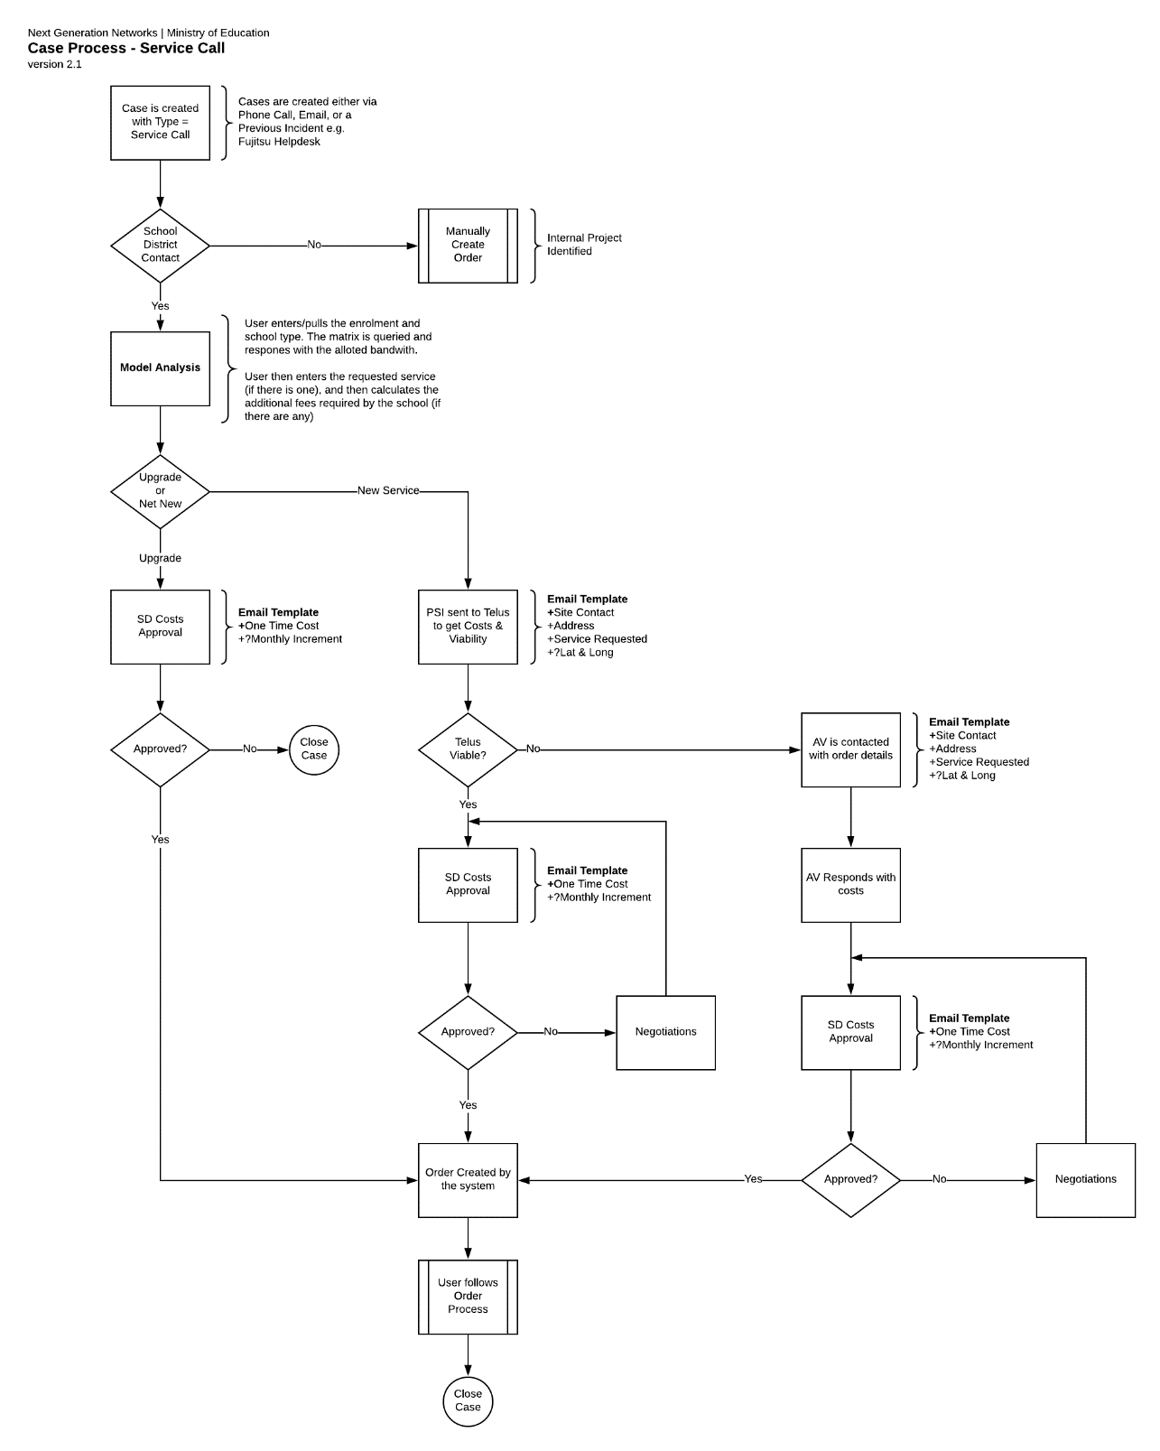

# Automation

## Order Type – Installation Date and Form Logic

The Order Type controls both the form logic and, when an installation date is entered, a workflow will fire, wait until the installation date, and then depending on the ORDER TYPE, Site services will be created/edited/deactivated.

This logic is defined below:

* **Order Type: 'new internet' || 'new wan'**
  + Form Logic: Requested Service – mandatory
  + Action: CREATES A NEW SITE SERVICE
* **Order Type: 'upgrade wan' || 'upgrade internet' || 'downgrade wan' || 'upgrade internet'**
  + Form Logic: Regarding Site Service - mandatory
  + Form Logic: Requested Service - mandatory
  + Action: EDITS THE SITE SERVICE
* **Order Type: 'remove port'**
  + Form Logic: Regarding Site Service - mandatory
  + Action: DEACTIVATES SITE SERVICE
* **Order Type: 'other'** 
  + e.g. server move - fibre move, IP addresses, etc.
  + Action: DOES NOTHING
* **Order Type: 'closure of service'**
  + Form Logic: Regarding Site Service - mandatory
  + Action: DEACTIVATES SITE SERVICE
* **Order Type: 'closure of site'**
  + Action: DEACTIVATES SITE
* **Order Type: 'add port'**
  + Form Logic: Regarding Site Service - optional
  + Form Logic: Requested Service - default to 'port'
  + Action: CREATES NEW SERVICE

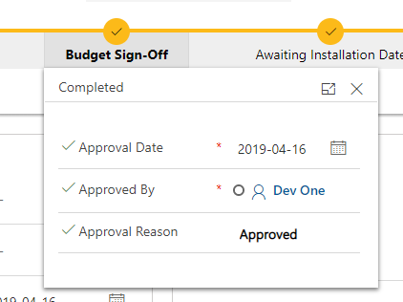

## Approval Logic

When the Approval Stage is entered on the business process flow, a workflow runs and creates an approval task for the Expense Authority.

The Expense authority will then use the following secure fields to approve the Order:

* Approval Date
* Approved By
* 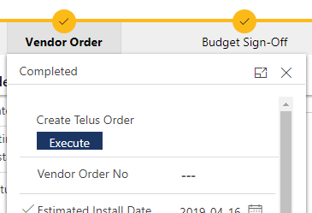Approval Reason

## Create TELUS Order

When the Order is in the Vendor stage, the Create TELUS order can be clicked, which will create a note with an attached document template attached.

This can then be downloaded and modified and then sent to the Vendor.

## Revised Scheduled Date

When the Revised Scheduled date is edited, a note is created in the Timeline, to track this change. This will then allow users to track the history of the Revised Scheduled Date.

# Business Process Flow – Order Flow

Dynamics uses a Business Process Flow to manage the stages of a case.

The image below shows the stages of the Order.

